**NAME: Fatima Majeed**

**ID NO: BIT-23F-046**

**COURSE: ARTIFICIAL INTELLIGENCE**

**SECTION: A**

**SEMESTER: 3RD**

**Lab 2. Variables to Python**

**LAB TASK 1:**

Make program to see if value is true of false.

**CODE:**

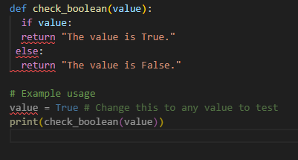

**OUTPUT:**



**LAB TASK 2:**

1. Make a calculator using the operands in the class.

**CODE:**

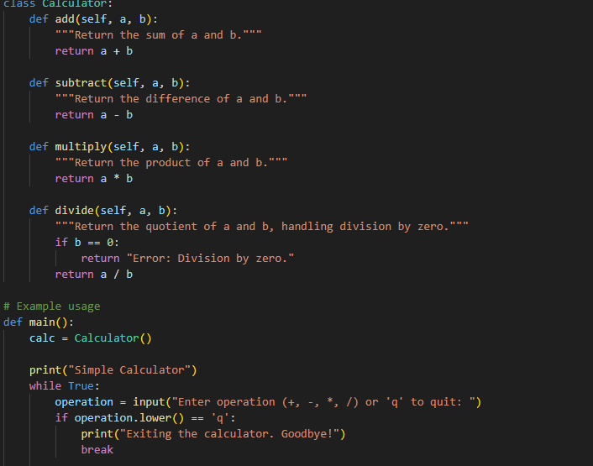

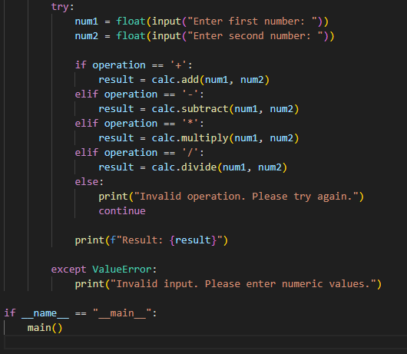

**OUTPUT:**

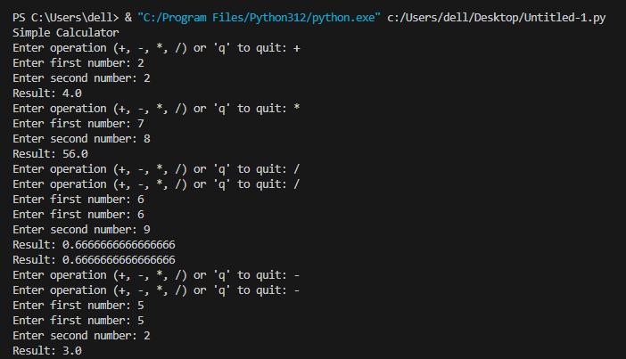

**LAB TASK 3:**

1. Write programs for the different type string “”,’’,””””””

**CODE:**

**Single Quotes (')**

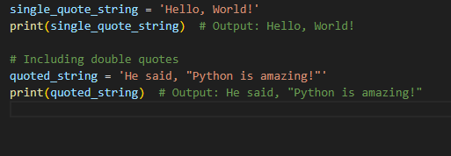

**OUTPUT:**

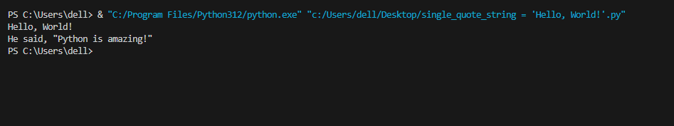

**Double Quotes (")**

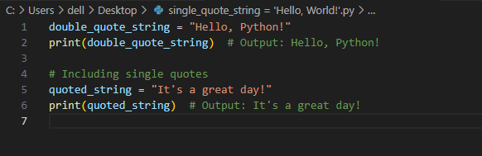

**OUTPUT:**

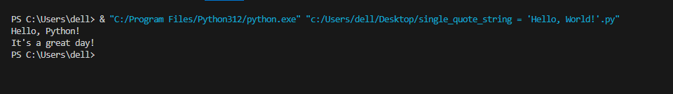

**Triple Quotes (''' or """):**

**CODE:**

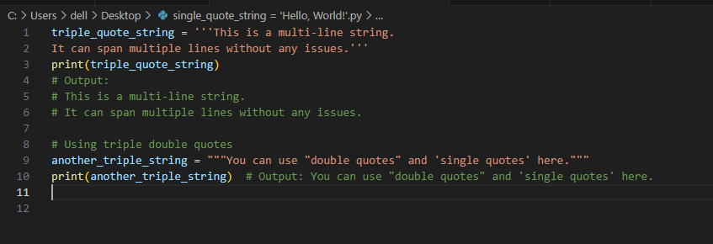

**OUTPUT:**

